Setting up Application Environment

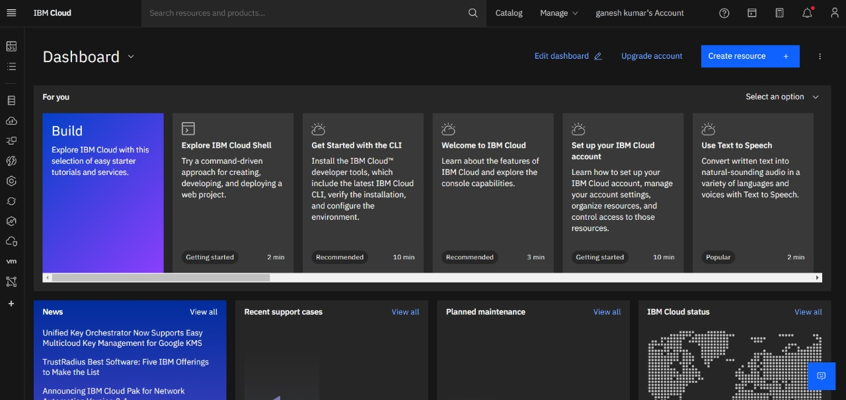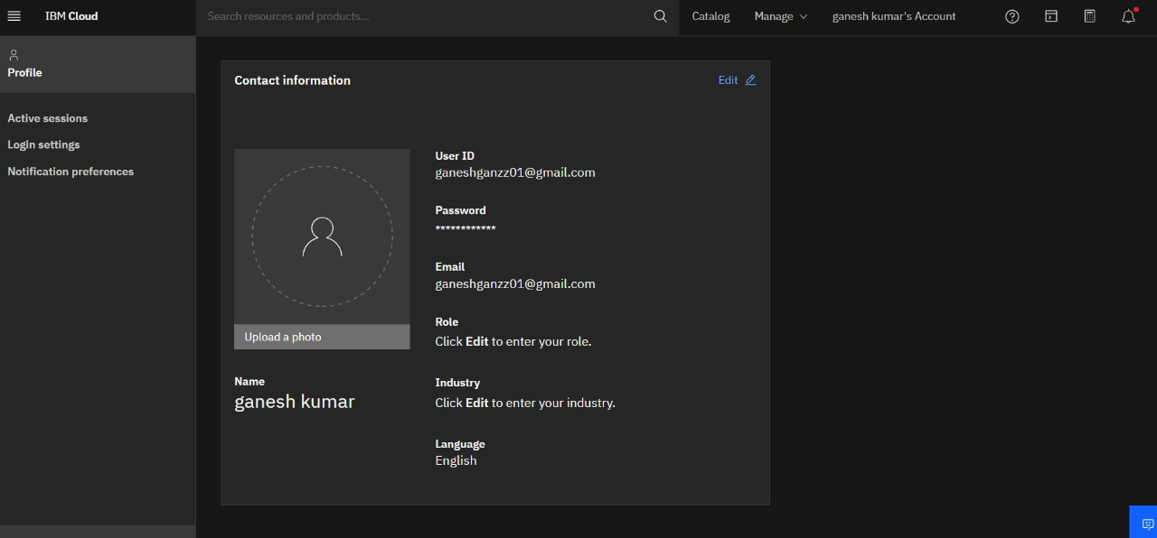

**Cloud Account as been Successfully created**

TEAM ID: PNT2022TMID39742